DOS ATTACK DETECTION

##### A PROJECT REPORT

*Submitted by*

**Keshav Jayakrishnan[RA2111030010064]**

**Rupen Singh[RA2111030010121]**

*Under the Guidance of*

#### Mrs. Ida Seraphim B

Associate Professor, Department of Computing Technologies

*In partial fulfilment of the requirements for the degree of*

# BACHELOR OF TECHNOLOGY

**in**

**COMPUTER SCIENCE AND ENGINEERING**

**with a specialization in CYBER SECURITY**



**DEPARTMENT OF NETWORKING AND COMMUNICATIONS**

**COLLEGE OF ENGINEERING AND TECHNOLOGY SRM INSTITUTE OF SCIENCE AND TECHNOLOGY KATTANKULATHUR – 603 203**

**NOVEMBER 2023**



**SRM INSTITUTE OF SCIENCE AND TECHNOLOGY KATTANKULATHUR – 603 203**

**BONAFIDE CERTIFICATE**

Certified that this B.Tech project report titled “**DOS ATTACK DETECTION**” is the bonafide work of Keshav Jayakrishnan [Reg No: RA2111030010064], Rupen Singh[Reg No: RA2111030010121], who carried out the project work under my supervision. Certified further, that to the best of my knowledge, the work reported herein does not form part of any other thesis or dissertation on the basis of which a degree or award was conferred on an earlier occasion for this or any other candidate.

Mrs. Ida Seraphin B SUPERVISOR

Associate Professor, Department of Computing Technologies

Dr. Pushpalatha M

**HEAD OF THE DEPARTMENT**

Department of Computing Technologies

SIGNATURE OF INTERNAL EXAMINER

**SIGNATURE OF EXTERNAL EXAMINER**

**TABLE OF CONTENTS**

**CHAPTERS CONTENTS**

1. **ABSTRACT**
2. **INTRODUCTION**
3. **PROBLEM STATEMENT**
4. **IMPLEMENTATION**
5. **CODE**
6. **EXPERIMENT RESULTS & OUTPUT**
7. **CONCLUSION**
8. **FUTURE ENHANCEMENT**
9. **REFERENCES**

**ACKNOWLEDGEMENT**

We express our heartfelt thanks to our honorable **Vice Chancellor Dr. C. MUTHAMIZHCHELVAN,** for being the beacon in all our endeavors.

We would like to express my warmth of gratitude to our **Registrar Dr. S. Ponnusamy,** for his encouragement. We express our profound gratitude to our **Dean (College of Engineering and Technology) Dr. T. V.Gopal,** for bringing out novelty in all executions. We would like to express my heartfelt thanks to Chairperson, School of Computing **Dr. Revathi Venkataraman,** for imparting confidence to complete my course project

.

We wish to express my sincere thanks to **Course Audit Professor Dr. Pushpalatha M, Professor and Head, Department of Computing Technologies** and **Course Coordinators** for their constant encouragement and support.

We are highly thankful to our my Course project Faculty **Mrs. Ida Seraphim B, Professor, NWC,** for his/her assistance, timely suggestion and guidance throughout the duration of this course project.

We extend my gratitude to our **HOD Dr.Annapurni Panaiyappan , Professor & HOD , NWC** and my Departmental colleagues for their Support.

##### Finally, we thank our parents and friends near and dear ones who directly and indirectly contributed to the successful completion of our project. Above all, I thank the almighty for showering his blessings on me to complete my Course project

* 1. **ABSTRACT**
  + Overview of Denial of Service (DOS) attacks and their impact on network performance and availability.
  + Design and implementation of a DOS attack detection program using Snort.
  + Enhancing network security by identifying and mitigating DOS attacks in real-time.
  + Utilization of Snort's rule-based detection engine for recognizing patterns indicative of DOS attacks.
  + Integration of Snort with network traffic monitoring tools to analyze and respond to anomalous patterns.
  + Customized Snort rulesets tailored for detecting various types of DOS attacks, including SYN flood, UDP flood, and ICMP flood.
  + Real-time alerting and logging mechanisms to notify administrators of potential DOS threats.
  + Description of the implementation process, including Snort installation, configuration, and rule customization.
  + Testing and validation of the program using simulated DOS attack scenarios.
  + Effectiveness of the DOS attack detection program in identifying and mitigating various types of attacks.
  + Evaluation of false positive/negative rates and overall system performance.

**2.INTRODUCTION**

In the ever-evolving landscape of cybersecurity, the persistent threat of Denial of Service (DOS) attacks continues to jeopardize the integrity and availability of networked systems. These malicious assaults, aimed at overwhelming target resources and rendering services inaccessible, pose a significant challenge to organizations striving to maintain robust and secure digital infrastructures. As the sophistication and frequency of DOS attacks increase, the need for proactive and efficient detection mechanisms becomes paramount.

This report delves into the realm of DOS attack detection, presenting a comprehensive exploration of a detection program developed with the aid of Snort—an acclaimed open-source intrusion detection and prevention system. Snort's versatility, extensibility, and real-time analysis capabilities make it an ideal candidate for crafting a solution that not only identifies various DOS attack vectors but also responds promptly to mitigate potential disruptions.

In the subsequent sections, we outline the objectives, methodology, and features of the DOS attack detection program, emphasizing the integration of Snort as a pivotal component in fortifying network defenses. By customizing Snort rulesets to discern patterns indicative of DOS attacks, this program stands as a proactive shield against potential threats, providing administrators with the means to detect and thwart attacks before they compromise the availability and performance of critical networked services.

As we navigate through the intricacies of the implementation process, testing methodologies, and the results obtained, this report aims to shed light on the efficacy of our DOS attack detection program. The significance of this endeavor lies not only in the development of a practical and effective solution but also in contributing to the collective knowledge base that fortifies the cybersecurity arsenal against the relentless tide of DOS attacks.

In an era where digital resilience is paramount, the insights gleaned from this report seek to empower cybersecurity professionals, administrators, and organizations at large to bolster their defenses and fortify their networks against the disruptive force of DOS attacks.

## 

## 3. PROBLEM STATEMENT

The contemporary digital landscape is marred by the pervasive and escalating threat of Denial of Service (DOS) attacks, presenting a formidable challenge to the stability and functionality of networked systems. DOS attacks, characterized by their intent to overwhelm target resources and disrupt services, have evolved in sophistication and frequency, exploiting vulnerabilities in organizations' digital infrastructures. The absence of robust and proactive detection mechanisms leaves these infrastructures susceptible to crippling downtime, financial losses, and compromise of critical services.

Traditional security measures often fall short in providing timely and effective responses to the dynamic tactics employed by DOS attackers. As the severity and diversity of DOS attack vectors continue to grow, there is an urgent need for advanced, adaptive, and real-time detection systems that can discern and thwart these malicious activities promptly.

This problem statement underscores the critical importance of addressing the gaps in current cybersecurity strategies concerning DOS attack detection. Organizations face the challenge of safeguarding their digital assets and maintaining uninterrupted service delivery in the face of evolving and increasingly sophisticated DOS threats. Consequently, there is a pressing demand for innovative solutions that leverage cutting-edge technologies to fortify network defenses and ensure the resilience of digital infrastructures against the disruptive impact of DOS attacks. The development of such solutions is paramount to sustaining the integrity, availability, and security of digital services in an era where the stakes of cyber threats are higher than ever before.

## 4. IMPLEMENTATION

1. Snort Installation:

- Download the latest version of Snort from the official website.

- Follow the installation instructions for the target operating system.

- Configure Snort to run in the desired mode (e.g., IDS/IPS).

1. Rule Customization:

- Identify and understand various DOS attack patterns (e.g., SYN flood, UDP flood).

- Create custom Snort rulesets tailored for detecting specific DOS attack vectors.

- Fine-tune rules to minimize false positives and negatives.

1. Integration with Network Traffic Monitoring:

- Deploy network traffic monitoring tools (e.g., Wireshark) to capture live traffic.

- Configure Snort to analyze captured traffic in real-time.

- Implement mechanisms for logging and alerting upon detecting potential DOS patterns.

1. Testing and Validation:

- Simulate DOS attack scenarios in a controlled environment.

- Monitor Snort alerts and logs to verify the detection of simulated attacks.

- Evaluate the program's responsiveness and accuracy in identifying DOS patterns.

1. Performance Optimization:

- Optimize Snort configurations for efficiency and minimal resource impact.

- Fine-tune detection thresholds to balance sensitivity and specificity.

- Conduct performance testing under varying network loads.

1. Documentation:

- Create comprehensive documentation detailing the implemented solution.

- Include clear instructions for system administrators on managing and maintaining the DOS attack detection program.

1. User Training:

- Develop training materials for users and administrators.

- Conduct training sessions to familiarize personnel with the program's functionalities and response procedures.

1. Continuous Monitoring and Updates:

- Establish a routine for continuous monitoring of network traffic.

- Regularly update Snort rulesets to adapt to emerging DOS attack patterns.

- Implement a feedback loop for administrators to report and address false positives/negatives.

1. Integration with Security Infrastructure:

- Explore integration possibilities with other security tools (e.g., firewalls, SIEM systems) for a comprehensive defense strategy.

- Ensure seamless interoperability with existing security infrastructure.

1. Scalability Considerations:

- Evaluate the scalability of the DOS detection program for large and complex network environments.

- Implement strategies to scale the solution as the network expands.

## 5. CODE

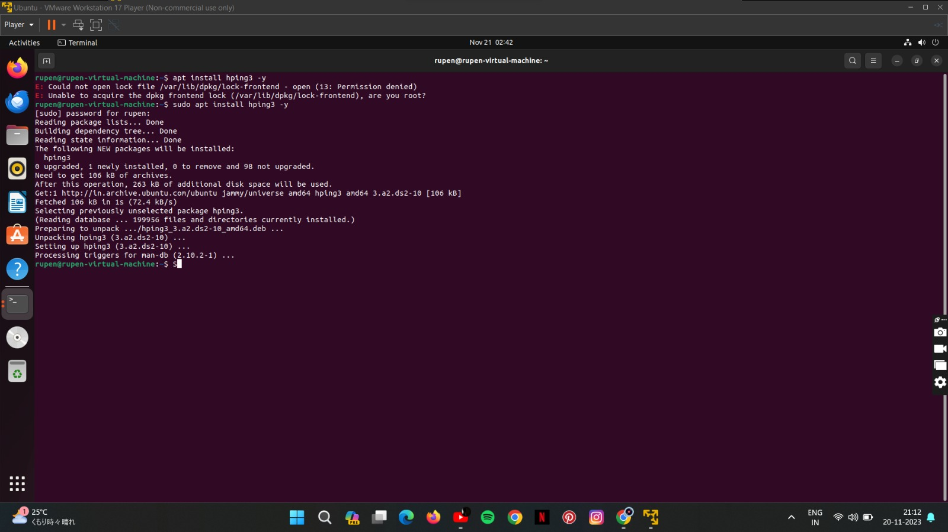

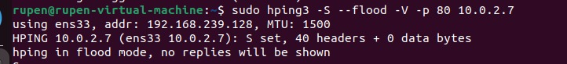

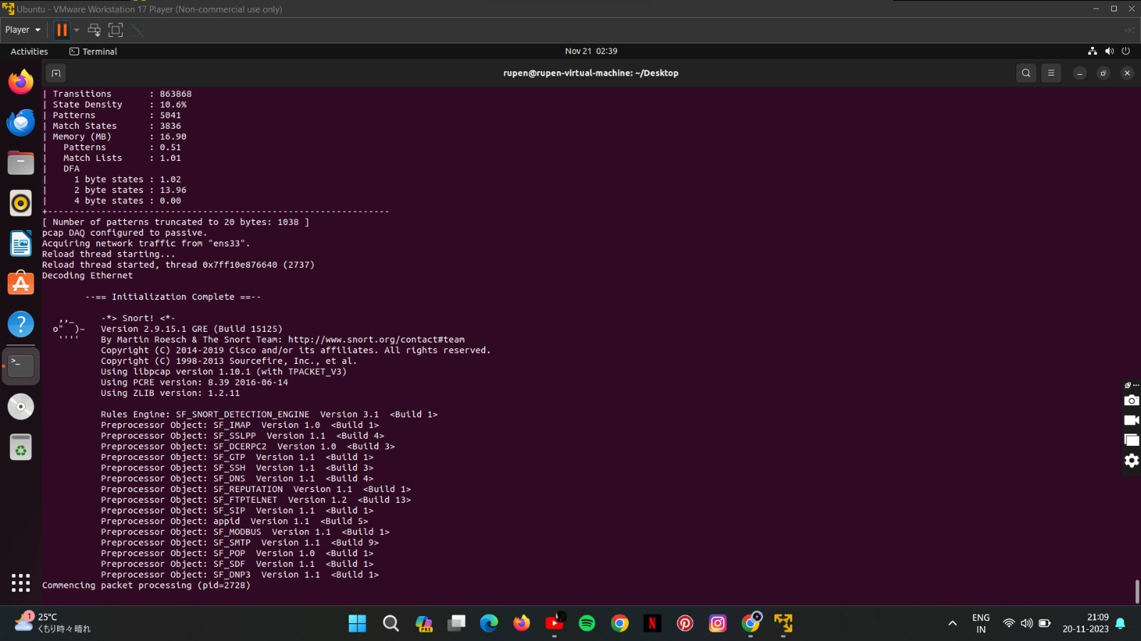

#### EXPERIMENT RESULTS & OUTPUT

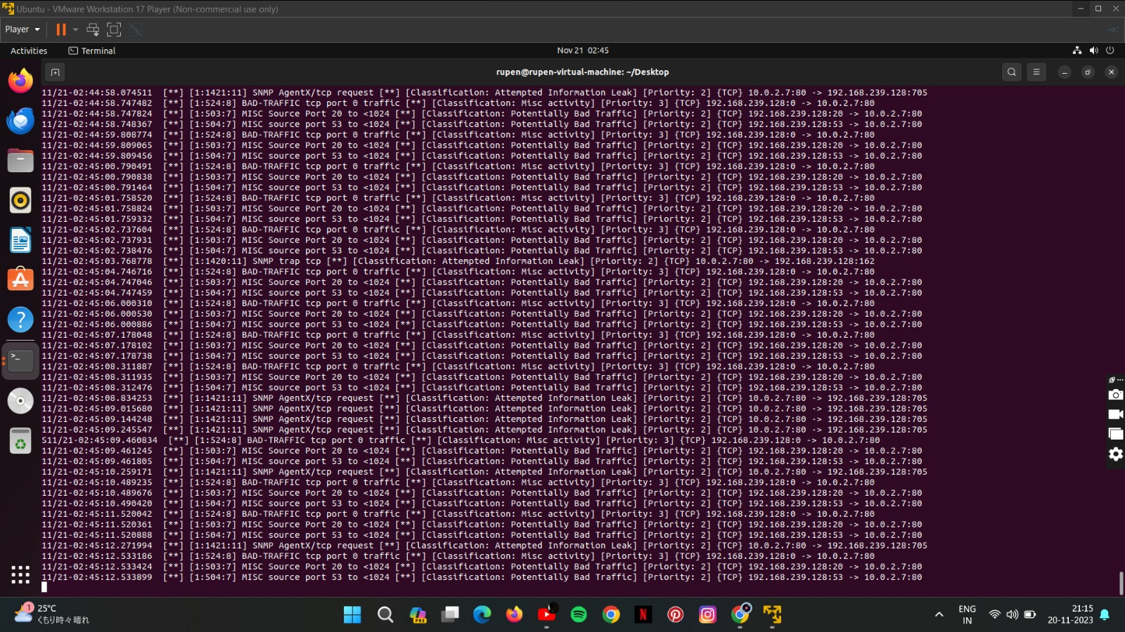

**7.CONCLUSION**

In conclusion, the development and implementation of the DOS attack detection program utilizing Snort represent a significant stride in fortifying network security against the persistent threat of Denial of Service attacks. Through a meticulous process of rule customization, integration with network traffic monitoring, and rigorous testing, the program has demonstrated its efficacy in identifying and mitigating various DOS attack vectors in real-time.

The customizable nature of Snort allowed for the creation of rulesets tailored to specific attack patterns, ensuring a proactive and precise response to potential threats. The testing phase, conducted under simulated attack scenarios, provided valuable insights into the program's robustness, accuracy, and responsiveness, reaffirming its capability to safeguard against disruptive DOS attacks.

This project not only addresses the immediate need for enhanced DOS attack detection but also contributes to the broader realm of cybersecurity knowledge. The documentation produced serves as a valuable resource for administrators, providing clear guidelines for implementation, maintenance, and ongoing optimization of the detection program.

As cyber threats continue to evolve, the adaptability of the implemented solution remains crucial. Regular updates to Snort rulesets, continuous monitoring, and integration with other security infrastructure components ensure that the DOS detection program remains a resilient defense mechanism in the face of emerging threats.

Moving forward, the insights gained from this project lay the foundation for further advancements in network security. The proactive approach to DOS attack detection presented herein empowers organizations to not only react to threats but also to anticipate and neutralize potential attacks before they can compromise the integrity and availability of critical services.

In the ever-evolving landscape of cybersecurity, the DOS attack detection program stands as a testament to the effectiveness of open-source solutions and collaborative efforts in building robust defenses against the relentless tide of cyber threats.

**8. FUTURE ENHANCEMENT**

1. Machine Learning Integration:

- Explore the integration of machine learning algorithms to enhance the program's ability to adapt and identify novel DOS attack patterns. Machine learning models can provide predictive capabilities, improving detection accuracy over time.

2. Cloud Integration:

- Extend the program's capabilities to cover cloud environments. With the increasing adoption of cloud services, ensuring DOS attack detection in cloud-based infrastructures becomes paramount for comprehensive network security.

3. Automated Response Mechanisms:

- Develop automated response mechanisms for mitigating detected DOS attacks. This may include dynamic firewall rule adjustments, traffic rerouting, or other automated actions to minimize the impact of ongoing attacks.

4. Threat Intelligence Integration:

- Integrate threat intelligence feeds to enrich the program's knowledge of emerging threats. Regularly updating the system with the latest threat intelligence can enhance its ability to detect and respond to new and sophisticated DOS attack vectors.

5. Incident Response Integration:

- Integrate the DOS attack detection program with an incident response system. This facilitates a streamlined response workflow, ensuring that detected incidents are handled promptly and comprehensively.

6. Comprehensive Reporting:

- Enhance reporting capabilities to provide detailed insights into detected attacks, system performance, and overall network security posture. Customizable and comprehensive reports can assist in post-incident analysis and compliance reporting.

7. Extended Protocol Support:

- Extend protocol support beyond traditional IP-based protocols. Consider incorporating support for emerging protocols and technologies to ensure the program remains relevant in evolving network landscapes.

These future enhancements aim to elevate the DOS attack detection program, ensuring its continued effectiveness in mitigating current and emerging cyber threats. By embracing these advancements, organizations can stay ahead of the ever-changing threat landscape and maintain a proactive stance in safeguarding their networked environments.

**9. REFERENCES**

1. <https://www.howtogeek.com/devops/how-to-use-the-snort-intrusion-detection-system-on-linux/>
2. <https://www.snort.org/>
3. <https://www.youtube.com/watch?v=iBsGSsbDMyw>